**Steps to Deploy and Scale the application**

**Note:** Steps are mentioned in detail in ReadMe.md.

1. Follow the steps to install Kubernetes and minikube on windows machine specified in “.\Kubernetes_Assignment_Basics\ Installation_kubernetes.docx”
2. Open windows powershell and go to directory “\Kubernetes_Assignment_Basics\”.

>cd “.\Kubernetes_Assignment_Basics\”

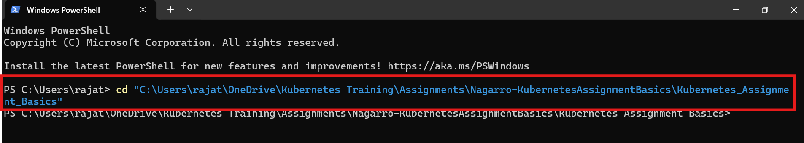

1. Deploy the application in Kubernetes cluster using “.\Deployment.yaml” in below command:

>kubectl create -f ./Deployment.yaml --save-config



1. To check the deployment:

>kubectl get all

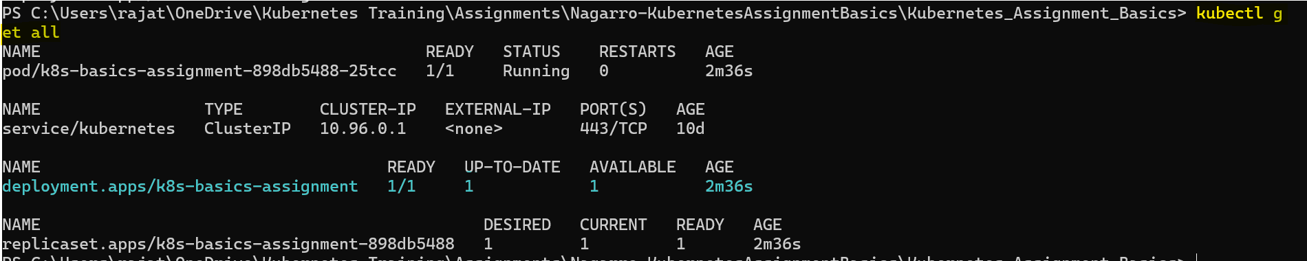

1. To expose the application:

>kubectl create -f ./Service.yaml --save-config



1. To check the created service:

>kubectl get services



1. To execute exposed application in local:

>minikube service k8s-basics-assignment-service

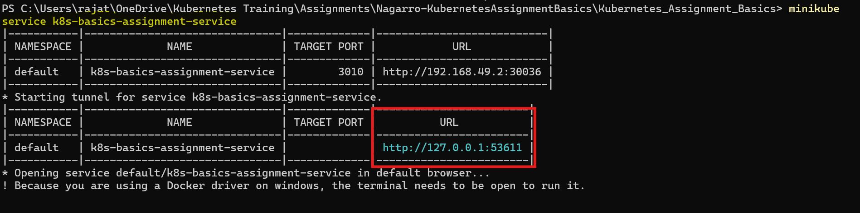

It will execute the webapp in default browser:

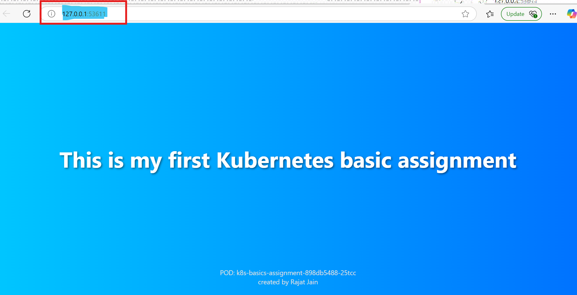

You may terminate the execution of the application by pressing ‘Ctrl+c’ or open another terminal and go to the same directory path as we did in step 2.

1. To scale the application:
2. Using command:

>kubectl scale deployment k8s-basics-assignment --replicas=3



>kubectl get pods



1. Updating Deployment.yaml:

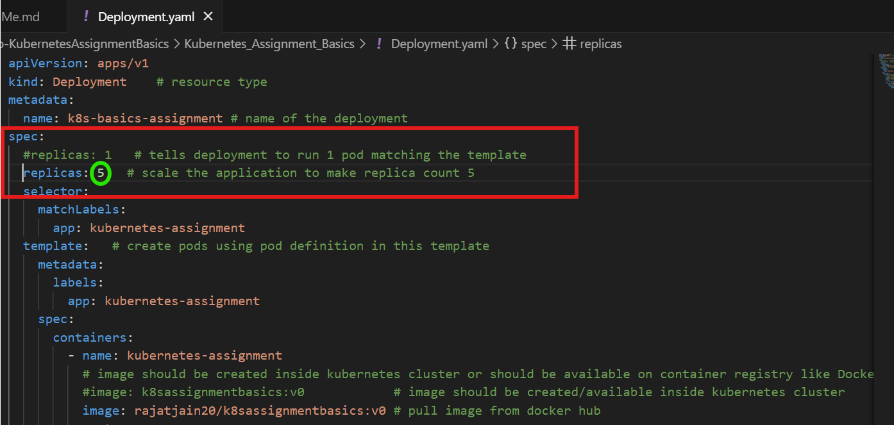

After updating Deployment.yaml. execute below command:

>kubectl apply -f ./Deployment.yaml

>kubectl get pods

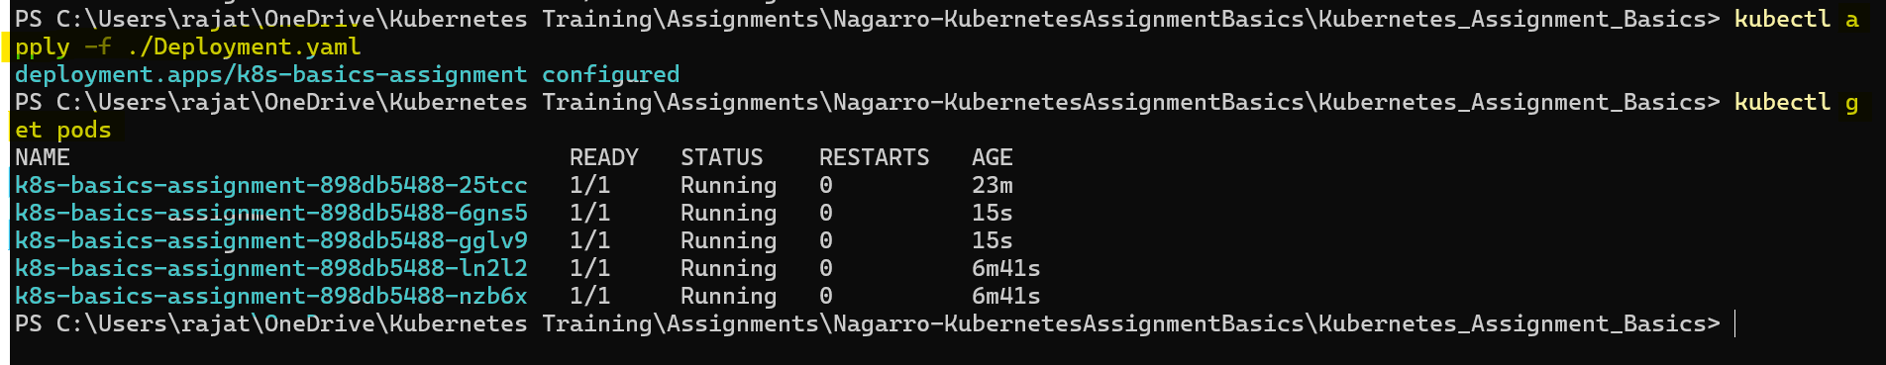

**Bonus Question:**

There is one more deployment file named “Deployment-Bonus.yaml” which has liveness and readiness probes configured.

1. To Deploy it and check the deployment:

>kubectl create -f ./Deployment-Bonus.yaml --save-config

>kubectl get deployment k8s-basics-assignment-bonus

>kubectl get all --selector app=kubernetes-assignment-bonus

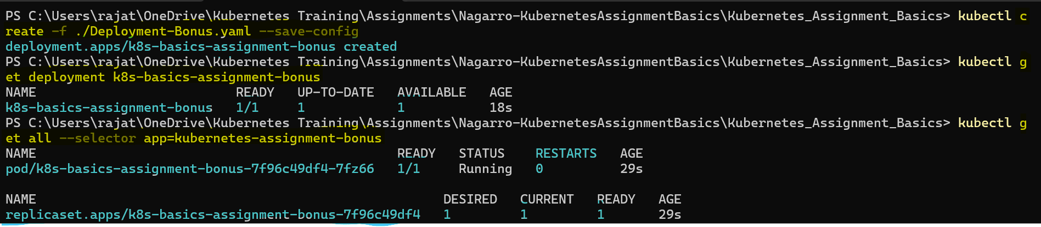

1. To expose the application and check the exposed service:

>kubectl expose deployment k8s-basics-assignment-bonus --name=k8s-basics-assignment-bonus-service --port=3020 --target-port=3000 --type=NodePort

>kubectl get service k8s-basics-assignment-bonus-service

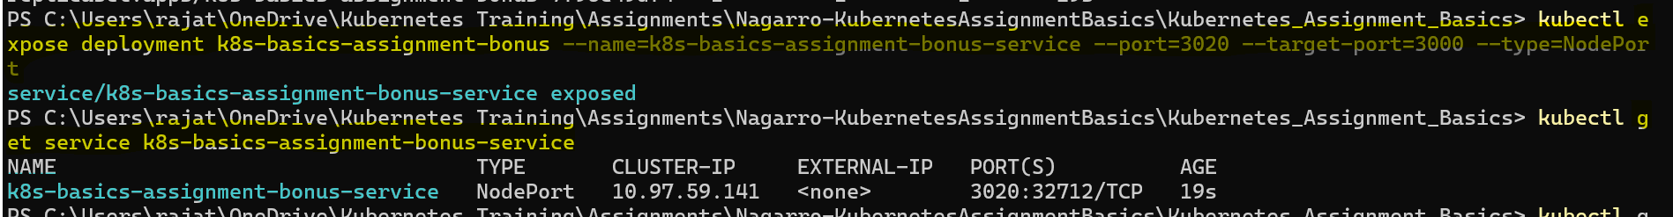

Check endpoint associated with this service:

>kubectl get endpoints k8s-basics-assignment-bonus-service -o wide



1. Lets check the deployment again:

>kubectl get all --selector app=kubernetes-assignment-bonus

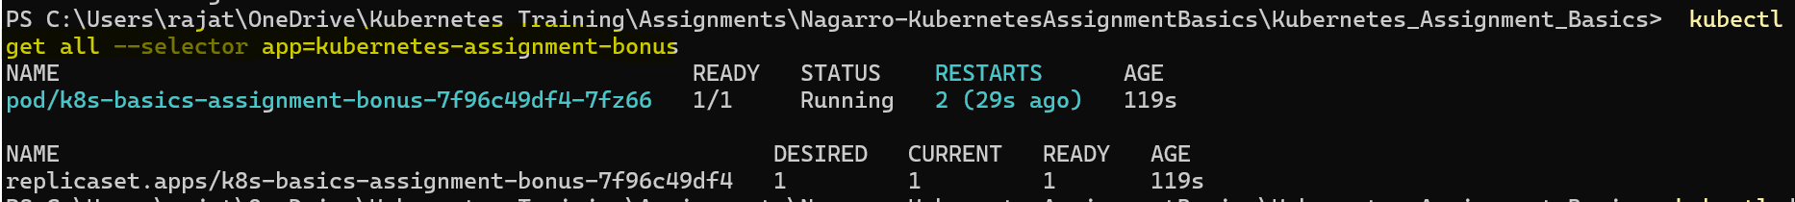

Pod restarted due to ‘livenessProbe’ failure.

1. Let's check the events in pod (pick the pod name from previous command):

> kubectl describe pod <Pod-Name>

Scroll down at the end of the powershell:

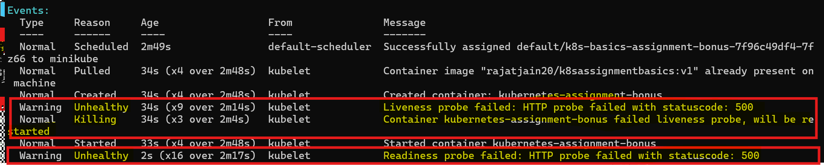

1. We can also check logs:

>kubectl logs pod/<Pod-Name>

Failure code (code 500) is returned when 30secs elapsed after server started and it keeps returning it till 50secs.

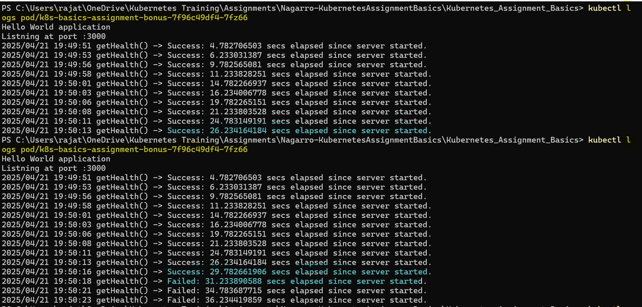

1. If we check the Endpoint associated with the service again after some time:

>kubectl get endpoints k8s-basics-assignment-bonus-service -o wide

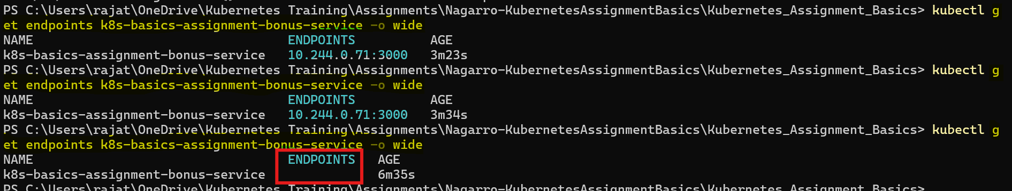

Endpoint has been removed that is because of Readiness Probe failure.